WSEA
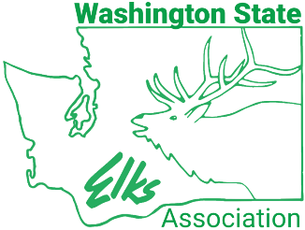
Officer Training
April 18, 2026
Agenda

Welcome to the Washington State Elks Association Officer Training at the Lakewood Lodge 2388.
Attire: State Uniform – Attendees will either be in state uniform, lodge uniform, or business attire.
Saturday, April 18, 2026
9:00-9:30 Opening
Invocation
Pledge of Allegiance
Roll Call of Lodges – Jim Henry, WSEA Officer Training Chair
Introduction of Dignitaries
Welcome Address – WSEA President Scott Rainey
9:30-10:00 Responsibilities of Lodge Officers – Caroline Bradwell, WSEA VP South
10:00-10:30 Ritual – Carrie Massey, WSEA Ritual Chair
10:30-10:45 Break
10:45-11:15 Running a Lodge Meeting Efficiently - Version II – Gil Mendoza, ER
11:15-11:45 Children’s hospital / Children’s Therapy - Jim Howes, PSP / John Fry, PSP
11:45-12:15 Veteran’s Support - Elizabeth Johnston, WSEA Veteran’s Chair
12:15-1:00 Lunch – Lunch served by the Lakewood Lodge
1:00-1:30 Charitable Trust, Vocational Grants – Lana Davik, VP East
1:30-2:15 Lodge Operating Expenses - Managing your Bar/Kitchen/Gambling – Brandi Wallace, PER
2:15-2:35 Grants and How They Support the Lodges – Dan Radley, Trustee & Grants, 2171
2:35-3:00 Community Activities – Tasha McMullen, PER, Dan Radley, Trustee 2171
3:00-3:30 Working with Volunteers – Tasha McMullin, PER / Robin Haley
3:30 Closing Remarks
Closing Prayer
Adjourn

