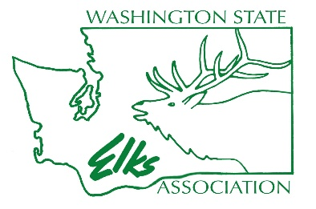

5 March 2026

To All Washington State Elk Lodges and members

We’ve refreshed our Washington State Elks Association training program to make it more fun and valuable for everyone. We kicked things off with an updated Winter Convention training, which was a great success. Jim Henry, our State Training Chairperson, along with our dedicated volunteer presenters and John Kristofzski, put in a lot of effort to create memorable sessions for participants to enjoy and bring back to their lodges and members.
Now we’re turning our attention to the Spring Training Program, which will take place on Saturday, April 18, 2026, at Lakewood Lodge #2388.
Exalted Ruler John Swanson has generously agreed to host this year’s event at their lodge, and we appreciate their hospitality.
Training will begin promptly at 9:00 AM, so please plan to arrive a little early to get settled.
Jim Henry is putting together another well-rounded agenda aimed at benefiting all attendees. Our goals include investing in our officers’ future, strengthening our lodges and programs, providing officer development training for effective lodge operations, and improving our community involvement.

The lodge has organized a great food and entertainment venue for Friday night and Saturday. Please see the attached advertisement. To help with preparations, please RSVP with the number of attendees from your lodge and pay for your meals by Friday, April 3, 2026. Please follow the instructions on the attached advertisement on RSVP and meal payment. Lodge information:
Ph# 253-588-2388, 6313 75th St. W. Lakewood, WA 98499. Email lakewoodelks2388@comcast.net

There is RV parking that is available. They do not make reservations. First come first served. Not a lot of usage during the spring so it should be ok.

Hotels close to the Lakewood lodge:
Holiday Inn Express 1751 Pacific Hwy SW Lakewood 866-803-8305
Comfort Inn 12704 Pacific HW SW Lakewood 253-367-4680 or 253-300-1760
Best Western Landmark 6125 Motor Ave Lakewood 866-994-3508
Woodsprings Suites 11329 Pacific Hwy Lakewood 253-215-4547
Americas Best 4215 Sharondale St SW Lakewood 866-994-8305

My goal for the year is to strengthen communication between the officer corps, our members, other lodges across the state, and our communities. Redesigning the training is just one part of achieving that goal. Exalted Rulers, all lodge officers, and future officers are highly encouraged to attend this training.

Fraternally
Scott Rainey
WSEA President

