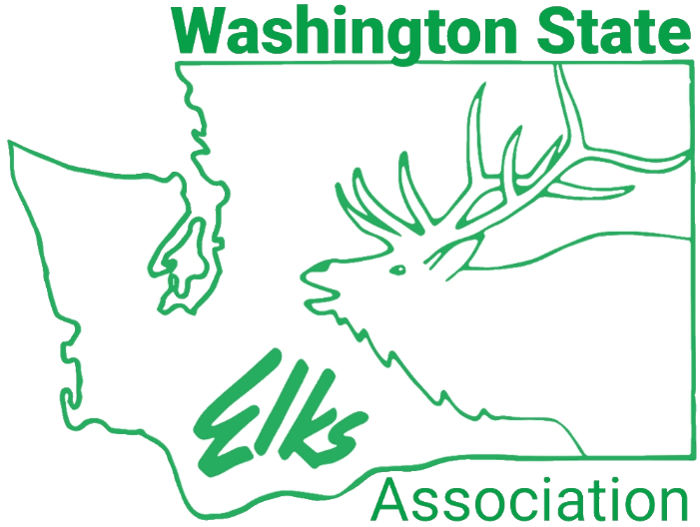

WSEA
Summer Convention
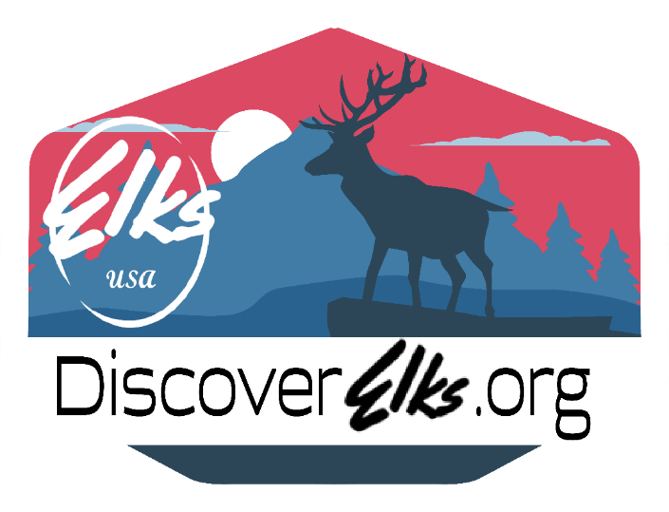
June 17-21, 2026
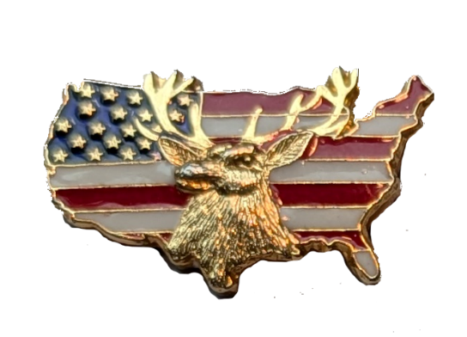
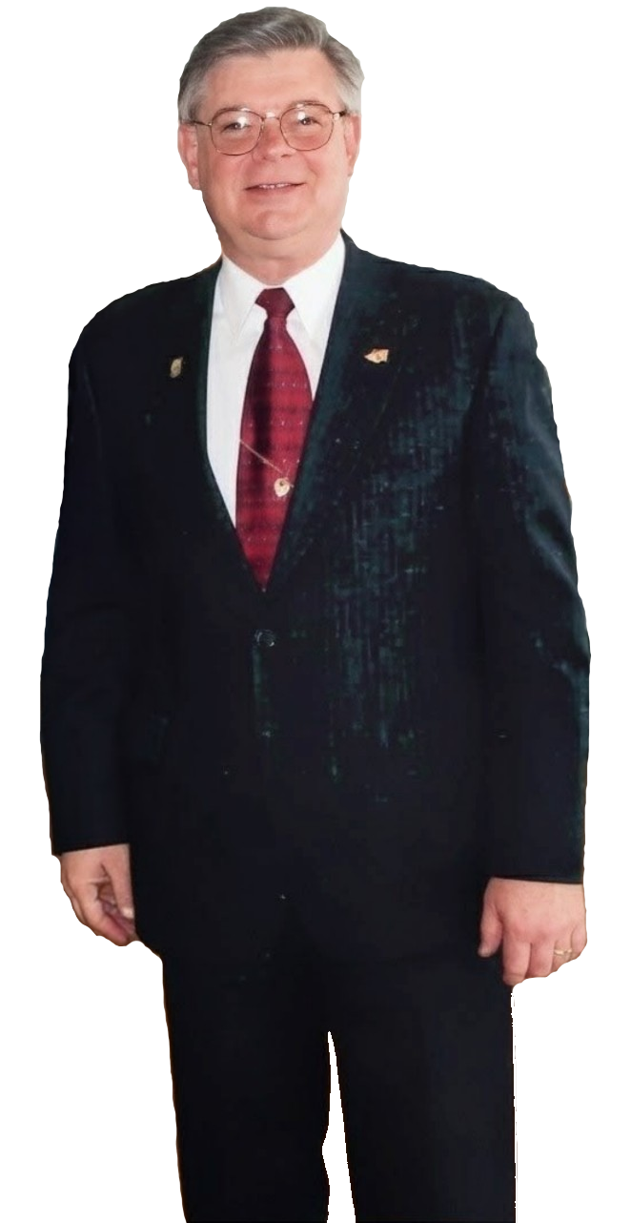
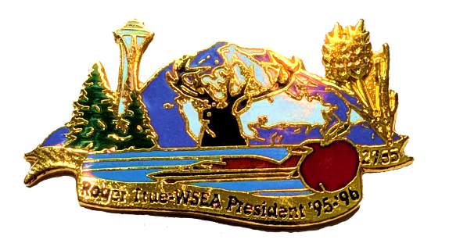
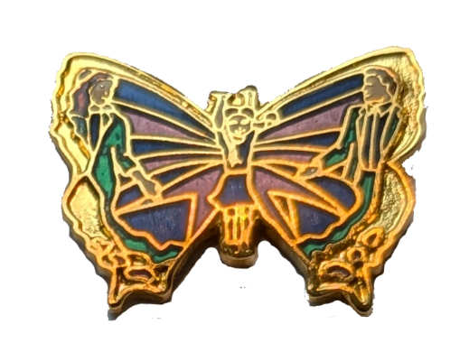
WSEA President
1995-1996
Tri-Cities Lodge #2755
A special thank you to Roger and Marilyn True for a lifetime of service to an organization that holds a special place in our hearts and communities.
Washington State Sponsor
2003 - 2026
Roger R. True
Past Grand Exalted Ruler
Grand First Lady
2002-2003
Grand Exalted Ruler
2002-2003

Expanded Agenda
Welcome to the Washington State Elks Association Annual Summer Convention in Pasco, Washington.
Many of you have attended our conventions before but in case you haven’t, the following may help you with a more descriptive detail of the convention events.
A digital version of this expanded and a regular agenda are available on our state website, waelks.org.
Full attire (dress code) descriptions can be found as an addendum to this agenda.

Wednesday June 17, 2026
State casual attire expected
3:00 – 5:00 WSEA Executive Board Closed Meeting Bronze
- Executive Board, State Sponor PGER, Advisor, visiting GER & PGER’s
Thursday June 18, 2026
State or Lodge Uniform that includes shirt/tie/jacket for sessions.
Business Casual for others.
7:30 – 5:00 WSEA Registration Olympic Foyer
8:00 – 10:30 WSEA, WECT, & WETP Corporation meetings Bronze
- Regular corporation meetings of the 3 entities, WSEA, WECT, WETP – general financial positions of each, Secretary & manager reports, committee reports, upcoming items of note, etc.
  - Report from WECT Fundraising Committee – Jill Anderson & Mike Dahl
  - Report from WECT Grants – Lana Davick & Ben Braden
9:30 – 11:30 *Handgun Trophy Shoot Off-Site
- Only for those Officers & Committee members w/no other commitments
- Shooters may participate in either morning or afternoon sessions, not both. Executive Committee can only participate after the 3:00p meetings conclude.
10:30 – 11:30 Therapy Action Committee meeting Bronze
- Incoming Committee Chair John Fry & Outgoing Committee Chair Lee Frankie.
- Run through new manual and appendixes to ensure everyone is on the same page with the expectations of the executive board on the focus and duties of the Therapy Action Committee.
- Finish with the Therapy Action Committee chair talking specifics about upcoming Golf, Bowling, Dinners, and other fundraising that requires Therapy Action Committee oversight, help, motivation and guidance.
- All Therapy Action Committee members are expected to attend.

11:30 – 12:30 Lunch On Your Own
12:30 – 1:00 Financial Trustee Meeting - Chair Richard Seeder Bronze
- General Financial Trustee Meeting incorporating any budget adjustments
1:00 – 2:00 State Committee Chair Meeting – Executive Board Bronze
Meet with the state committee chairs to share the Program Guide with an overview discussion, the general expectations of the committees Liaison and the Liaison committee – Quarterly reports, newsletter articles, vouchers, recording expenditures, etc.
- Break out into groups by Liaison and go over particular items to that connection.
- All 2026-2027 committee chairs expected to attend
1:30 – 4:30 *Handgun Trophy Shoot Off-Site
- Only for those Officers & Committee members w/no other commitments
- Shooters may participate in either morning or afternoon sessions, not both. Executive Committee can only participate after the 3:00p meetings conclude.
2:00 – 3:00 Convention Presenter Training – Chair Jim Henry Bronze
- All Elks doing presentations at Summer Convention to attend this meeting covering meeting room mechanics, expectation of speakers and getting feedback to improve.
- Discuss general presentation techniques to increase likelihood topics are retained and calls to action. Ideas on how to keep attendees engaged and how you as a speaker can more effectively pay attention to your audience.
3:00 – 4:00 Membership +1 Reception – by invitation Olympic
4:30 – 11:00 Hospitality rooms open Courtyard
5:30 -10:55 Entertainment provided by Davey Barber Courtyard
6:00 -9:00 Past State Presidents Reception Harvest Room
11:00 Eleven O’clock Toast – Courtyard

Important note: Exalted Rulers, to assist your Lodge, make plans ahead of the Friday training sessions, assign each person a specific session to attend so that your lodge gets all the important information.
Friday June 19, 2026
Red Shirt Friday in Honor of our Deployed Service Men and Women,
State or Lodge Uniform that includes shirt/tie/jacket for sessions.
Casual After in Courtyard
7:30 – 5:00 WSEA Registration open Olympic Foyer
8:00 – 9:00 District Caucuses – (See below for rooms)
North - Bin 20 South - Spruce East - Pine/Oak
West – Project (Workshop 1) Central – Design (Workshop 2)
9:10 – 10:40 Membership, Events, Reporting & Marketing Bronze/Silver
Membership - Wendy Cook, Lodge Activities – Tasha McMullin,
Government Relations - Julie Seeder, Marketing – Greg Heimgartner
- Do a hands-on walkthrough on creating the events, building the engagement and then finding the information needed to create letters and marketing that encourages new members to join, reinforces current members about their dues expense and convinces unpaid members to renew while enlightening your community. A collaboration between membership, lodge activities, government relations & marketing committees. All Exalted Rulers, Knights, Trustees & House committee members are expected to attend.
10:50 – 11:30 Profit & Loss 201 – Business Practices Ernie Bodoh Spruce
- The next in a series of courses to help you keep your lodge solvent. You learned about budget development at Winter Convention and the basics of evaluating lodge Bar, Kitchen & Gambling performance at spring officer training. This course advances those concepts and adds evaluation of your Financial Reporting System report and how to identify issues with examples and develop corrective actions to bring actuals in line with the budget.
10:50 – 11:30 Past Exalted Ruler Collaboration – Vice President’s Design
- Learn techniques for Exalted Rulers to transition from being the lodge CEO/President to valued advisor and support person. Cover opportunities available to help WSEA if you are interested in next steps.
10:50 – 11:30 Ritual – Chair Carrie Massey Oak/Pine
- Demonstrate and discuss the importance of PRACTICE & performing the ritual well for lodge membership retention and increasing meeting attendance, no matter if lodge is reading or reciting from memory. Share impressionable ideas like scrolls – where to get them made and how much they cost
11:00 – 1:00 Spouses Lunch (Ticketed Event, Registration Req.) Bin 20
- A lunch event intended for Non-Members and Members whose spouse or significant other is an Officer. Visiting Dignitaries and out of state Elks are welcome to join their spouses on this outing. Members and their spouses who are not officers or committee chairs can attend.
11:30 – 1:00 Lunch On Your Own
11:30 – 1:00 Private Past State Presidents Luncheon Project
1:00 – 2:00 Safety & Lodge Development - Chair Mike Campbell Design
- Our lodges are our homes, and our members are our family. Ensuring the safety of both is essential. Come learn how regular inspections provide opportunities to learn about your building needs, create future planning, and enhance your stewardship of the lodge ensuring maintained and well-founded lodges for future generations.
1:00 – 2:00 Cyber-Assistants & the Virtual Home Page Bronze/Silver
Online Presence Committee Chair Arnold Ross
- Focus on a hands-on presentation on how to do things and who can do them – encourage CLMS Cyber-Assistants to attend and bring your laptop with hotspot to get the most out of this session. Time will be spent on the Online Presence Contest scoring and who will be moved forward into the Grand Lodge Website contest.
1:00 – 2:00 All American Lodge Contest – Chair Tasha McMullin Pine/Oak
- This session builds on the All-American Lodge assignment from spring officer training. We will actively work on each lodge putting information into the sheet and go through what activities lead to points and where they can go on the form. We will cover dates of events and activities available (e.g. Ritual) to help your community Discover the Elks and to drive each lodge to higher levels of performance. We will have a discussion sharing easy things a lodge can do to increase lodge engagement & pride, while increasing points for the contest.
2:10 – 3:10 Therapy Program 101 – Therapy Committee Bronze/Silver
- Down to the Basics seminar about our impressive and expansive State Major Project. Every wonder how many therapists help how many families each year? Curious about the program’s budget, where its funding comes from and what it takes to be a therapist in the program? Want the ability to explain the program to your fellow members and friends? This is the seminar for you! Put on by the support and promotional committee of Therapy Program for Children so you hear firsthand from those who know the most and are the most excited about the program.
3:20 - 4:00 Grand Lodge Convention Information Bronze/Silver
Joe Basil & Benjamin Braden
4:30 – 11:00 Hospitality rooms open Courtyard
4:30 – 5:00 Installation of Officers Bronze/Silver
5:00 – 5:30 Cocktails & Table Seating (Dinner Ticket Req.) Olympic/Gold
5:30 – 5:45 Presidents Speech (Dinner Ticket Req.) Olympic/Gold
5:45/6:00 – 6:30 Dinner served (Dinner Ticket Req.) Olympic/Gold
State or Lodge Uniform that includes shirt/tie/jacket, Business Attire, or better, expected at the dinner and awards
6:30 – 9:00 State Awards Presentation w/ Celebration (open) Olympic/Gold
9:00 -10:55 Courtyard Music Entertainment Courtyard
11:00 Eleven O’clock Toast – WSEA Baby Past State President Courtyard
Saturday, June 20, 2026
State or Lodge Uniform that includes shirt/tie/jacket for sessions Business Casual for others.
7:30 – 12:00 WSEA Registration Olympic Foyer
8:00 – 10:00 Business Session Members only Bronze/Silver
(Introduction of dignitaries, Roll call of lodges, Introduction of DD Teams, Voting for new Budget, etc.)
10:00 – 10:30 Open Meeting Veterans – Elizabeth Johnston Bronze/Silver
- All Registered Members and Guests to attend
- Learn more about the amazing things Washington Elks have done and are doing for Veterans with a focus on excited recognition of what lodges have done for Veteran’s around the state and how the Charitable Trust Grants helped do more for Veteran’s this past year
10:30 – 11:30 Open Meeting Therapy Program – Fry/Frankie Bronze/Silver
- All Registered Members & Guests to attend
- Enjoy all new promotional material pertaining to the Therapy Program with a focus on exciting recognition of what Lodges have done to support the program, golf, bowling, dinners, etc.
11:30 – 1:00 Lunch On your Own
11:40 – 12:45 Polly Garland Luncheon Ticket Required Olympic/Gold
1:00 – 1:30 Memorial Service - PSP’s Bronze/Silver
- All Registered Members and Guests are welcome to attend
1:45 – 4:00 Open Session – Registered Members & Guests Bronze/Silver
- Promotional about our Charitable trust, it’s online fundraising efforts over the past year and what amazing things were done.
- Information about our State Celebration event to be held after the quarterly business meeting in Oak Harbor this coming October.
- The influence of a good deed, honestly and promptly performed, will continue forever. John Kristofzski is living that ideal on ridgelines in the west – learn about this amazing awareness and fundraising activity.
- Discover Elks promotional presented by founding Discover Elks Group member’s Past State President of Oregon, Blake Whitson and Past State President of Idaho, Sera White. Learn about the Cars Tour West and opportunities for Elks Nights at the track and within your lodge.
- Hear directly and personally from our Grand Exalted Ruler Bryan Klatt and how we each should be the difference that makes the Elks shine brightly.
- In our unique Washington State Elks style 3 different Past Grand Exalted Rulers will close out our convention – Roger True, Mike Luhr & Keith Mills.
4:00 – 11:00 Hospitality rooms open Courtyard
5:30 -10:55 Courtyard Music Entertainment Courtyard
6:00 - 7:00 Barbecue Dinner (Ticket Required) Olympic/Gold
11:00 Eleven O’clock Toast - ER of the Year Courtyard
WSEA Officer Uniform (Dress Code)
Below is what you can expect the WSEA officers to be wearing.
Anything at a similar level from your state, lodge or business is acceptable attire.
- FORMAL DRESS CODE DEFINITION:
  - Black Tuxedo w/ vest/cummerbund/button covers, bow tie, and black shoes.
    - A long, floor-length evening dress; a very fancy cocktail dress or dressy slacks and dressy blouse, dressy shoes may be substituted for female officers.
- SEMI-FORMAL DRESS CODE DEFINITION:
  - A dark suit, necktie, and black dress shoes.
    - A cocktail dress or slacks with dressy blouse and dressy shoes may be substituted for female officers.
- STATE UNIFORM DRESS CODE DEFINITION:
  - A sports coat of Kelly Green that was previously approved as the official state coat by the Washington State Elks Association Executive Committee.
    - This is the official coat for all the Washington State Elks Association elected and appointed Officers, committee chairs/members and all other state positions of any type.
  - A white dress shirt.
    - A white blouse may substitute a white dress shirt for female officers.
  - The official Washington State Elks Association necktie.
    - A sash/scarf may substitute the official Washington state necktie for female officers.
  - A pair of black dress pants.
    - A plain black dress or knee-length (or longer) skirt may be substituted for the trousers.
  - Shoes, socks, and belt shall be black in color.
  - A State approved name badge giving the wearer’s name and position held should be worn on the Sports Coat pocket or similar area for female officer’s dress choice.
  - Exalted Rulers when attending Grand Lodge Convention will also wear the state uniform when attending functions requiring this dress code.
  - Past Exalted Rulers from Washington State Lodges can wear this uniform at functions requesting this dress code as appropriate.
  - In support of our deployed veterans, a red dress shirt should be worn on Friday’s.
    - A red blouse or dress may substitute a red dress shirt for female officers.
- STATE CASUAL – BUSINESS CASUAL DRESS DEFINITION:
  - In the event of an occasion (such as a picnic, golf tournament, meeting or outing) where the state elected/appointed officers, committee chairs or member wishes to represent the Washington State Elks Association and state/business casual is requested, or the dress codes described above would be out of place and no dress code is defined, they may wear Green/White or Red Washington State Elks Association logo button down short sleave dress shirt or polo shirts available from the State Office with slacks/trousers, or skirt for females.
    - Shorts may be worn when appropriate for the situation, but they will be at a business quality level.

TOGETHER WITH PURPOSE

2026–2027 Presidential Theme
Together with Purpose defines what our Association needs to thrive in the years ahead. Our purpose is clear and shared by every member: the success of our lodges and the success of the Elks. To achieve this, we must shift from working within isolated lanes to embracing true interdependence with coordinated committees, supportive leaders, and intentional cooperation at every level.
“Together” means acting with shared responsibility. Every Executive Board member must fully embrace their liaison role while recognizing that no committee stands alone. When one succeeds, we all advance; when one struggles, we all feel the impact. Collaboration, information-sharing, and joint problem-solving are not optional, they are the foundation of a healthy, functioning Association.
Accountability becomes supportive and constructive. Committee chairs will feel respected, empowered, and guided, especially during challenges. An Executive Board that maintains regular contact and upholds quarterly reporting to ensure progress while offering encouragement and clear direction is one that will have active successful committee programs.
Adaptability is essential. Challenges will come, but our strength will be defined by how quickly we respond while keeping our purpose at the center of every decision.
Together with Purpose means leaders who are engaged, committees that collaborate freely, and liaisons who actively support their teams. When we operate this way, intentionally, cooperatively, and with urgency we build not only a successful year, but a stronger, more vibrant Washington State Elks Association for the future.

